

Dynamics 365 Manufacturing Accelerator

Configuration Guide

**Published**: May 2020

**Accelerator Release Version**: May 2020

Table of Contents

Introduction 3

Prerequisite Files 3

Main Solutions 3

Additional Solutions 4

Configuring of EDI JSON Testing Steps 4

Add your swagger JSON file to Web Files 4

Add Web Page for JSON Testing 6

Add your Web Page with JSON URL 11

# Introduction

The purpose of this document is to provide a guide on configuring Dynamics 365 Manufacturing Accelerators solutions.

# Prerequisite Files

The solutions related to this industry have been imported by following the **Dynamics 365 Manufacturing Solutions Installation Guide V1.docx** document.

# Configuring of EDI JSON Testing Steps

## Add your swagger JSON file to Web Files

To add your swagger json file to Web Files follow these steps:

1. Navigate to <https://make.powerapps.com/home> > Select your Environment > Click Apps in left-hand Navigation.
2. Click “Portal Management” Model Driven App.
3. In Portal Management App, Click Web Files in left-hand Navigation.
4. Click New Button on top.

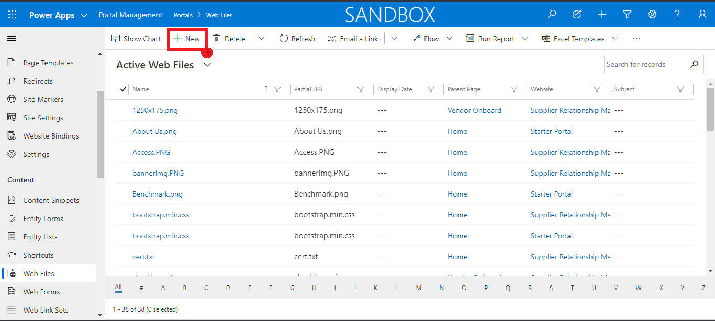

1. After clicking New Button, Now fill this page’s General Tab first and Click Save then.

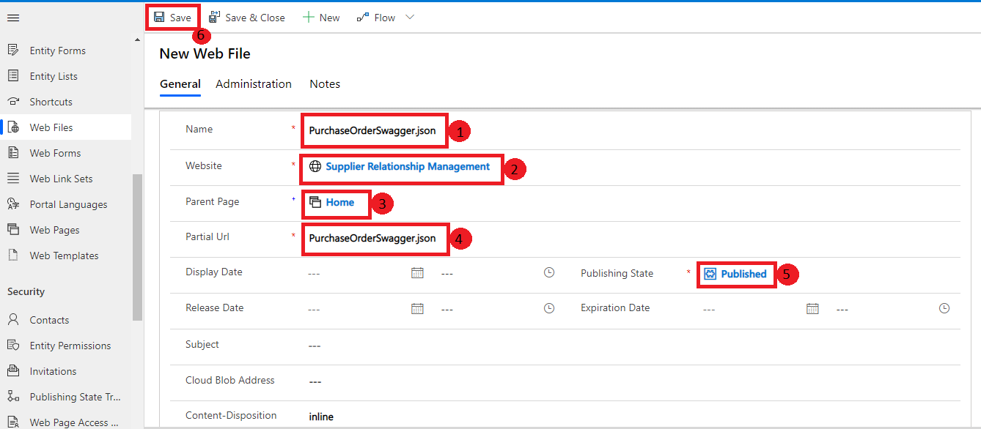

1. Now shift to Notes tab and add your json file in it.

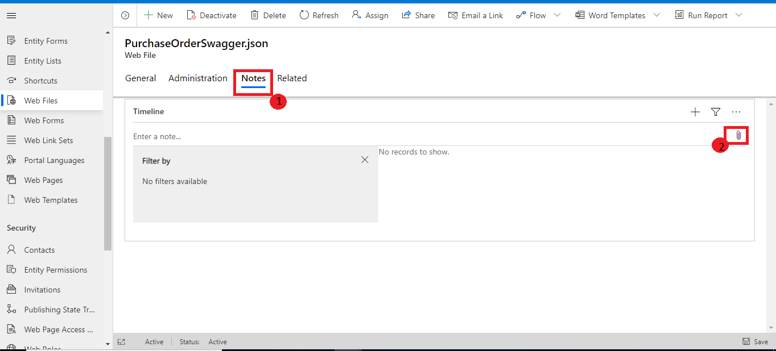

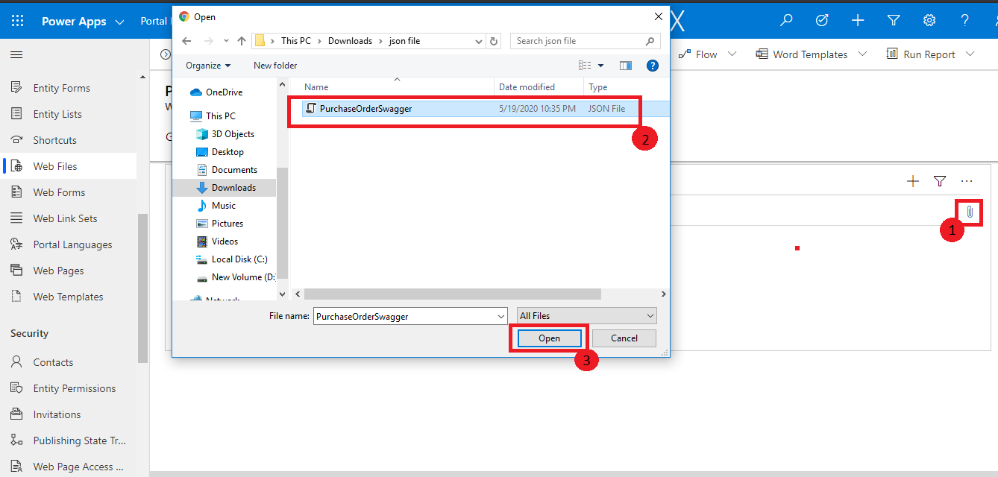

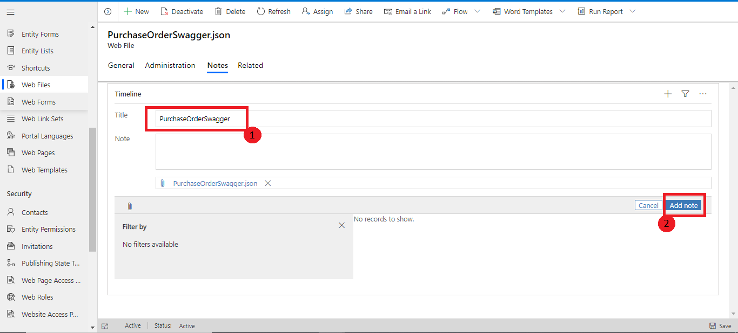

## Add Web Page for JSON Testing

To add Web Page follow these steps:

1. In Portal Management App, Click Web Pages in left-hand Navigation.
2. Click New Button on top.

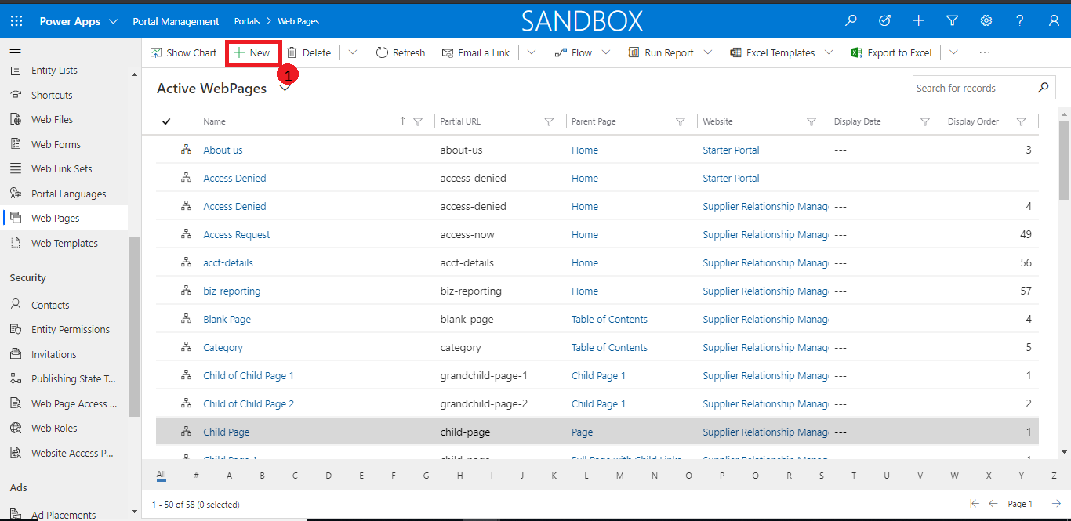

1. After clicking New Button, Now fill this page’s General Tab first and Click Save then.

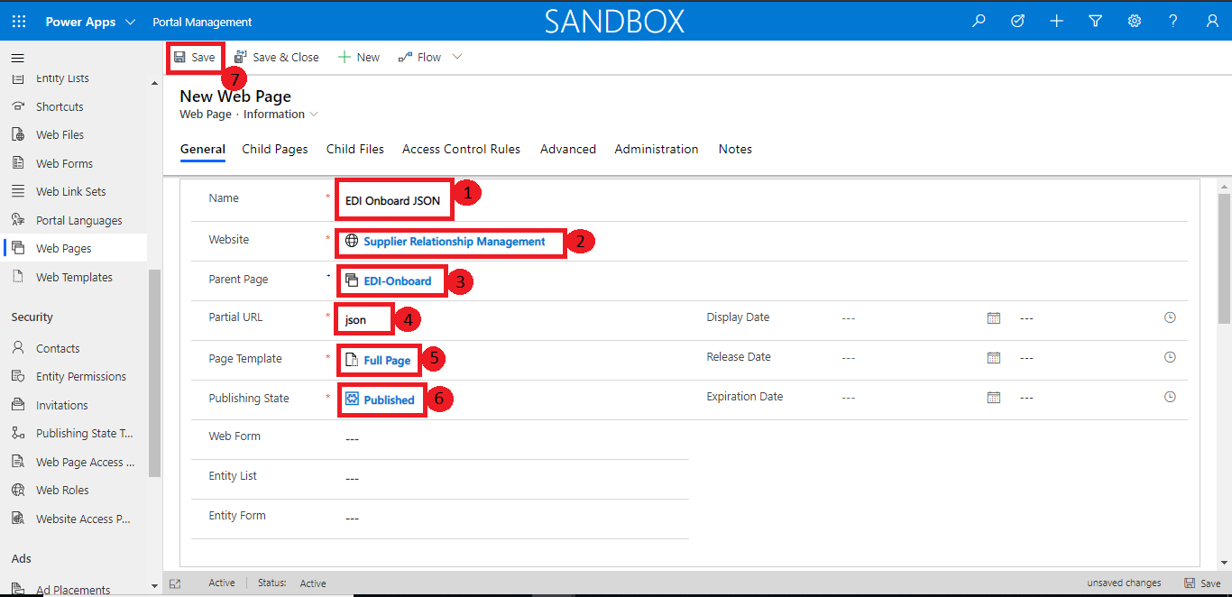

1. Now scroll down and click on the Content Page to open it.

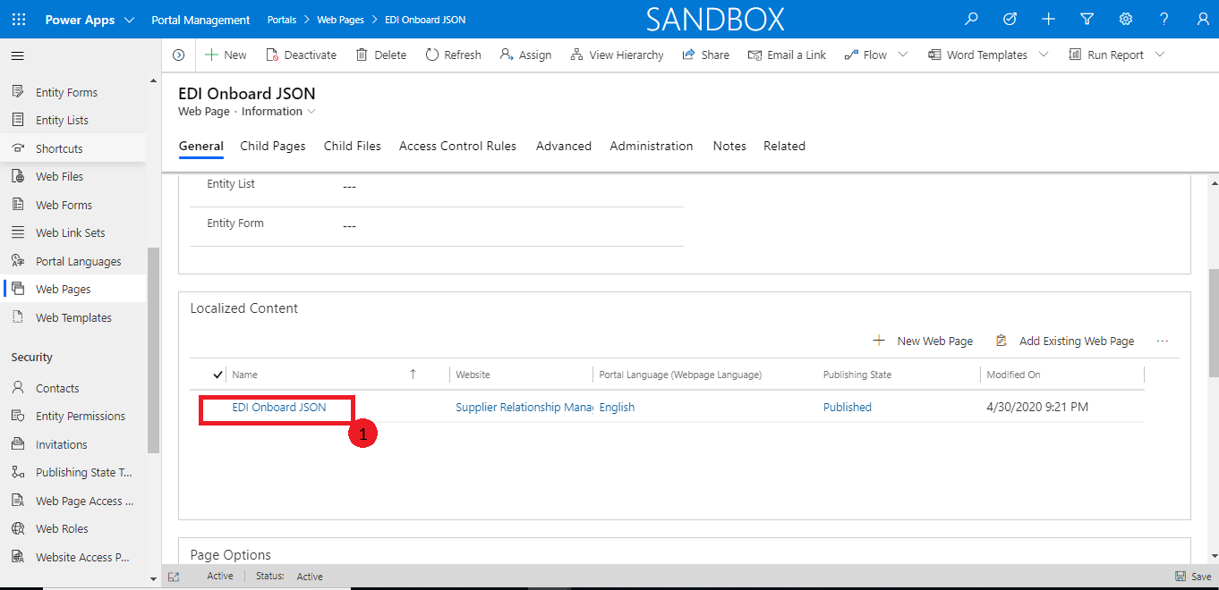

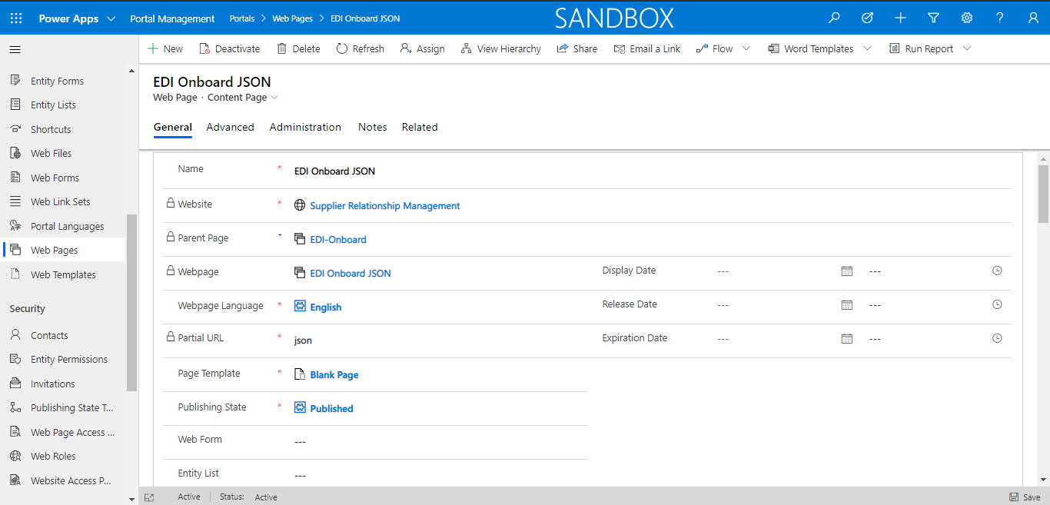

1. Scroll Content page down to “Copy (HTML)” and select ‘HTML’ Option.

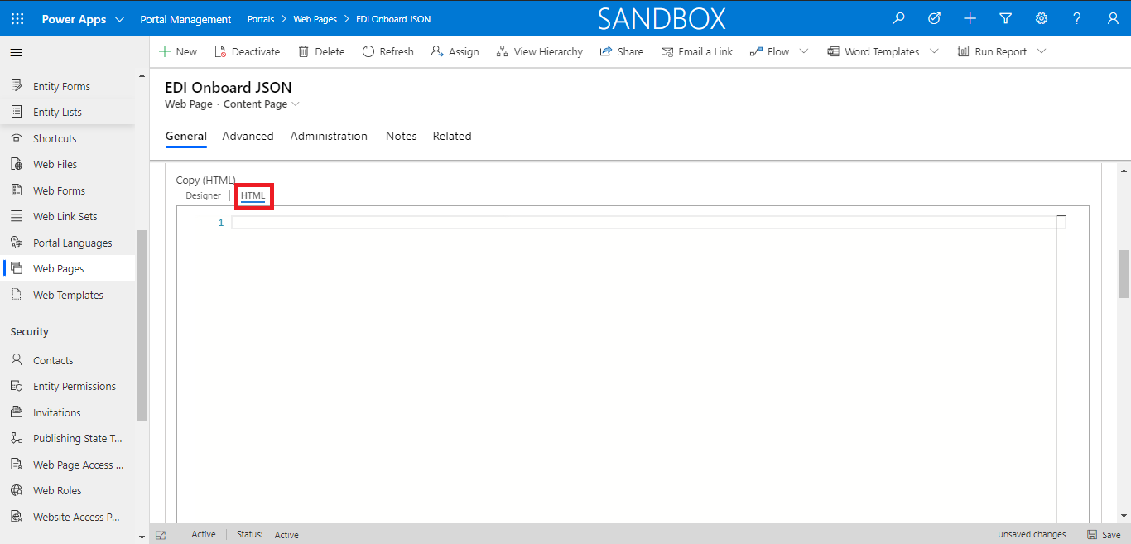

1. Now paste this code in text area below and click the Save button in the right bottom of this text area.

<!-- HTML for static distribution bundle build -->

<!DOCTYPE html>

<html lang="en">

<head>

<meta charset="UTF-8">

<title>Swagger UI</title>

<link rel="stylesheet" type="text/css" href="https://cdnjs.cloudflare.com/ajax/libs/swagger-ui/3.24.2/swagger-ui.css" >

<link rel="icon" type="image/png" href="./favicon-32x32.png" sizes="32x32" />

<link rel="icon" type="image/png" href="./favicon-16x16.png" sizes="16x16" />

<style>

html

{

box-sizing: border-box;

overflow: -moz-scrollbars-vertical;

overflow-y: scroll;

}

*,

*:before,

*:after

{

box-sizing: inherit;

}

body

{

margin:0;

background: #fafafa;

}

</style>

</head>

<body>

<div id="swagger-ui"></div>

<script src="https://cdnjs.cloudflare.com/ajax/libs/swagger-ui/3.24.2/swagger-ui-bundle.js"> </script>

<script src="https://cdnjs.cloudflare.com/ajax/libs/swagger-ui/3.24.2/swagger-ui-standalone-preset.js"> </script>

<script>

window.onload = function() {

// Begin Swagger UI call region

const ui = SwaggerUIBundle({

url: "https://suppliermanagementportal.powerappsportals.com/PurchaseOrderSwagger.json",

dom_id: '#swagger-ui',

deepLinking: true,

presets: [

SwaggerUIBundle.presets.apis,

SwaggerUIStandalonePreset

],

plugins: [

SwaggerUIBundle.plugins.DownloadUrl

],

layout: "StandaloneLayout"

})

// End Swagger UI call region

window.ui = ui

$(document).ready(function(){

$(".topbar").hide();

});

}

</script>

</body>

</html>

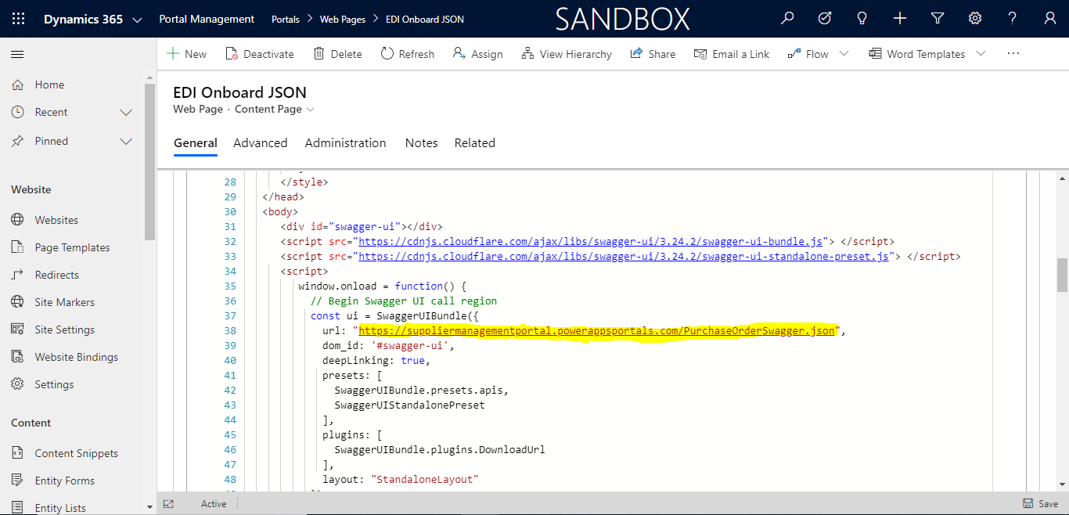

## Add your Web Page with JSON URL

To add your webpage with JSON Url follow these steps:

1. In Portal Management App, Click Web Pages in left-hand Navigation.
2. Search for ‘EDI Onboard JSON’ Page and open it.
3. Scroll down page and open content page.





1. Scroll Content page down to “Copy (HTML)” and select ‘HTML’ Option.
2. Create the URL as (Your Portal URL + Web File Name).

Eg. https://msmfgsupplierdev.powerappsportals.com/+ PurchaseOrderSwagger.json

https://msmfgsupplierdev.powerappsportals.com/PurchaseOrderSwagger.json

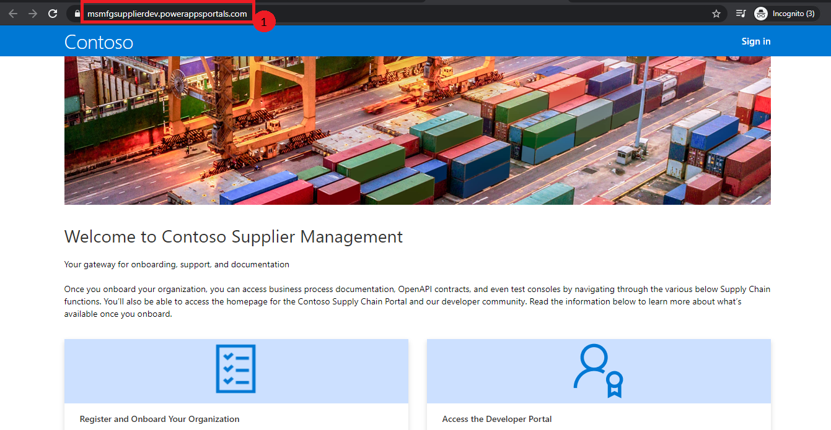

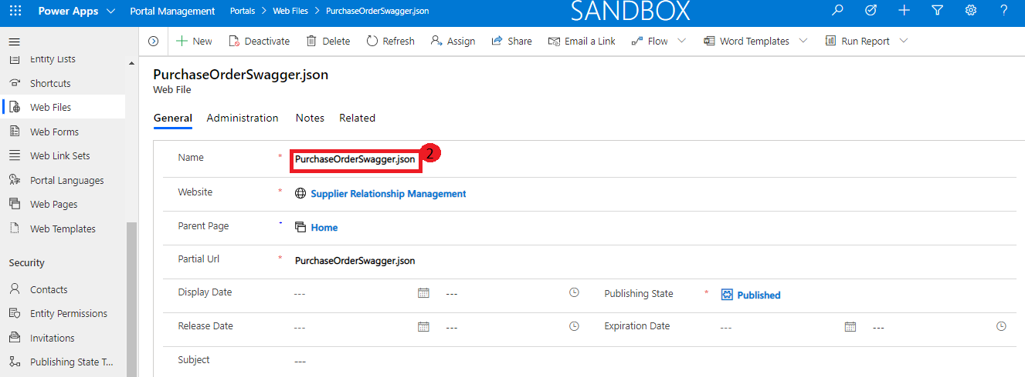

1. Replace this URL in EDI Onboard File Page as highlighted.



1. Now open Portal and add ‘/_services/about’ in Portal URL and then Click on Clear Cache button.

